Performance Report

Grant Award ID: F16AFXXXXX02

Grant Award Title: KY – Sport Fish Stocking and Fish Hatchery Operations/Maintenance

Grant Award Period of Performance: January 1, 2016 – December 31, 2016

Type of Performance Report: Final

Performance Reporting Period: January 1, 2016 – December 31, 2016

STRATEGY – SPECIES REINTRODUCTION & STOCKING
OBJECTIVE 1 – Stock 3,240,300 fish by December 31, 2016.

# of Fish Stocked | Species Stocked | Percent of Total Objective | Action Level Reporting | Deadline
14,000 | Muskellunge | 0.43% | Activity Tag 1: Prod/Stocking for recreational purposes  Activity Tag 2: Put-Grow-and-Take | December 31, 2016
1,115,000 | Walleye | 34.41% | Activity Tag 1: Prod/Stocking for recreational purposes  Activity Level 3: Put-Grow-and-Take | December 31, 2016
735,000 | Striped Bass | 22.68% | Activity Tag 1: Prod/Stocking for recreational purposes  Activity Level 3: Put-Grow-and-Take | December 31, 2016
550,000 | Hybrid Striped Bass | 16.97% | Activity Tag 1: Prod/Stocking for recreational purposes  Activity Level 3: Put-Grow-and-Take | December 31, 2016
110,000 | White Bass | 3.39% | Activity Tag 1: Prod/Stocking for recreational purposes  Activity Level 3: Put-Grow-and-Take | December 31, 2016
237,500 | Largemouth Bass | 7.33% | Activity Tag 1: Prod/Stocking for recreational purposes  Activity Level 3: Put-Grow-and-Take | December 31, 2016
54,500 | Blue Catfish | 1.68% | Activity Tag 1: Prod/Stocking for recreational purposes  Activity Level 3: Put-Grow-and-Take | December 31, 2016
117,500 | Channel Catfish | 3.63% | Activity Tag 1: Prod/Stocking for recreational purposes  Activity Level 3: Put-Grow-and-Take | December 31, 2016
60,000 | Sauger | 1.85% | Activity Tag 1: Prod/Stocking for recreational purposes  Activity Level 3: Put-Grow-and-Take | December 31, 2016
250,000 | Rainbow Trout | 7.72% | Activity Tag 1: Prod/Stocking for recreational purposes  Activity Level 3: Put-and-Take | December 31, 2016
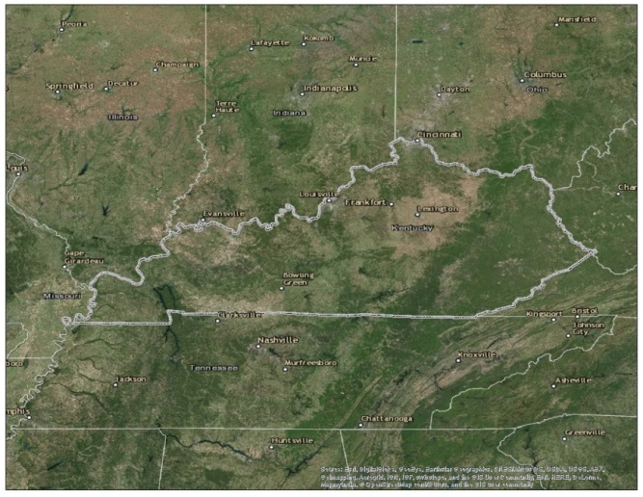

STRATEGY – FACILITY CONSTRUCTION; FACILITY & AREAS O&M
OBJECTIVE 2 – Operate and maintain 2 facilities by December 31, 2016.

# of Facilities | Type of Facility | Percent of Total Objective | Action Level Reporting | Deadline
2 | Hatcheries | 100% | Activity Tag 1: Hatcheries  Activity Tag 2: Recreational purposes | December 31, 2016

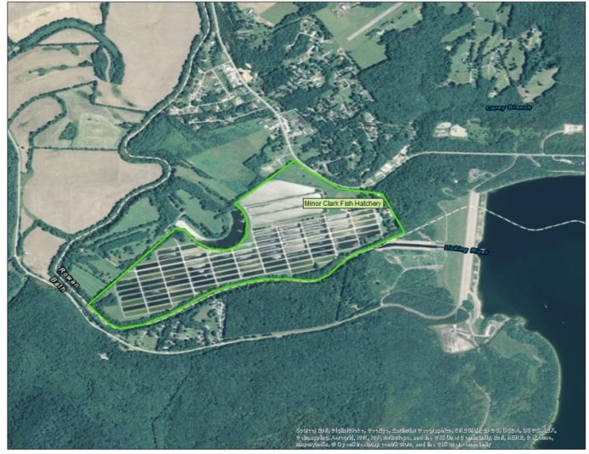
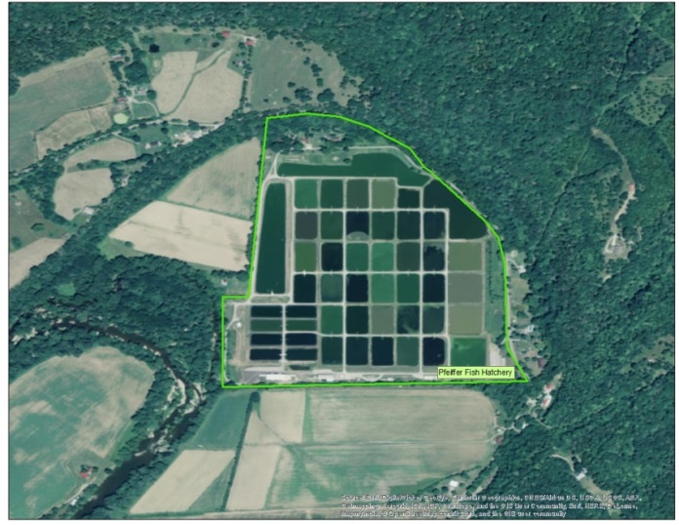

Performance Reporting
- What progress have you made toward completion of the objectives of the project? Describe how your objectives were met?

Both fish hatcheries successfully achieved the objectives of the grant in terms of producing fish for stocking and maintaining each facility as proposed in the project statement.

A significant snow fall event (25+ inches) and below normal temperatures occurred through much of Kentucky during February that resulted in delayed brood fish collection activities. Therefore, all brood fish collections occurred during the first and second weeks of March. This postponement resulted in increased collections of musky, walleye, and sauger brood fish as a result of water temperatures being slightly warmer and greater relative abundance of prespawn fish in historic sampling areas. Beyond this early inconvenience, the remainder of the fish production and stocking season was implemented as outlined in the project statement. A total of 3,243,500 fish were stocked during the period of performance. This was an increase of 3,200 fish from the proposed 3,240,300. The excess production was comprised entirely of muskellunge.

Additionally, both fish hatcheries were adequately operated and maintained during the period of performance as proposed in the project statement. As planned, new roofs were installed at both the main office building and one hatchery residence house at Pfeiffer Fish Hatchery. The new roofs have an expected useful life of 20 years. Additionally, a new sump pump was also installed at one hatchery residence house at Pfeiffer Fish Hatchery. Since its installation, the basement no longer floods during significant rainfall events.

At Minor Clark, a new well pump was installed that will increase the amount of well water made available to the hatchery during periods where the primary source of water (Cave Run Lake) is unavailable. The expected useful life of the new well pump is 15 years. All other operational and maintenance activities, as outlined in the project statement, were performed during the period of performance to ensure that both facilities are able to meet the fish production and stocking needs of the KDFWR.

- Did you deviate from the approved objective(s) or approach(es) during the reporting period? If so, please describe the deviation(s) and justification(s) for such deviation(s). What factors (labor resources, financial resources, policies, weather conditions, change in agency priority, etc.) impacted your ability to accomplish the objective(s)?

There were no deviations to the approved objectives or approaches during the period of performance. All target fish species were successfully propagated and reared at both fish hatcheries.

Minor Clark Fish Hatchery successfully produced and stocked more muskellunge than was originally anticipated. A total of 14,000 muskellunge were stocked, while only 10,800 were originally planned for stocking. Excess muskellunge were evenly split and stocked at Cave Run Lake and Green River Lake. The excess muskellunge resulted from above average numbers of eggs collected, as well as above average hatching success of fertilized eggs.

- If applicable, how did the completion of this project help to inform your agency’s future management decisions?

Both Minor Clark Fish Hatchery and Pfeiffer Fish Hatchery are nearing 100% production capacity with the current demand of species and available facility capabilities. Any new or future production demands could potentially require a cut of current production species and/or numbers in order to accommodate any new production needs. There is expansion potential and/or modernizations that could increase production capabilities at both hatcheries, but these would both require significant financial investments. Any new production requests, both from fisheries staff or the public, will require the KDFWR to assess the validity of such requests and determine a cost/benefit analysis in order to determine if additional production capabilities may be possible.

- If this grant continues work from a previous grant, how do current results compare to prior years? Please attach any relevant supporting documentation.

This grant continues the work of previous sport fish production and operation and maintenance grant funded activities at the KDFWR’s two state-owned fish hatcheries. The objectives and actual accomplishments of this grant are similar to previous grants (typically the only objective that changes is the actual number of sport fish stocked from year to year). The types of species and actual numbers requested for stocking are based upon KDFWR fisheries biologist’s requests which are determined by analyzing annual sampling data for each species at each resource. In the event that more species/numbers of sport fish are requested than can be produced, then the Fisheries Division executive leadership determines priority ranking of what resources will be produced on an annual basis. The species produced during this grant period represent that highest priority of the Fisheries Division for this calendar year. In terms of hatching success, pond survival, total length at stocking, and disease/depredation loss, the hatchery managers all reported that these were similar to previous year’s numbers.

- Were there any cost efficiencies achieved or any new cost-efficient practices developed as a result of this project? If so, please describe.

New oxygen diffusers were installed on all hatchery trucks during the grant period. These new diffusers are more efficient at delivering dissolved oxygen to each fish compartment which ultimately helps to improve survival of fish during transit from the hatchery to the stocking location. Additionally, the new diffusers are more cost effective which helps to reduce the number of oxygen tanks that the agency must purchase on an annual basis. Transportation staff anticipates that these new oxygen diffusers will result in 20% less oxygen consumption throughout the year. The new diffusers should realize cost saving efficiencies in under 2 years.

- Did the project result in any unexpected benefits, promising practices, or lessons learned that should be shared with peers? If so, please describe.

Staff at Minor Clark Fish Hatchery continue to refine the propagation and culture practices of muskellunge. Minor Clark Fish Hatchery is considered one of the leading authorities for the culturing of muskellunge in the Southeast. Staff have published numerous papers over the years that have improved freshwater culture techniques for muskellunge throughout the United States. Staff are presently attempting to refine their techniques for improving hatching success and minimizing bacterial infestation of muskellunge eggs using enhanced water quality and temperature management strategies.

Additionally, staff at Pfeiffer Fish Hatchery continue to refine the propagation and culture practices of hybrid striped bass. Over the last several years, staff have developed a domesticated brood stock of female striped bass that can be held on-site in larger brood ponds. The benefit of this practice is that wild stocks may not need to be harvested annually and undergo the significant stress from collection techniques and transportation to the hatchery complex. Such stress can often degrade the quality of eggs from female brood fish and result in lower hatching success. If female striped bass can be held on-site, this would minimize the need for wild brood fish to be collected annually.

- Identify and attach any publications, photographs, screenshots of websites, or other documentation that have resulted from this project, including articles in popular literature, scientific literature, or other public information products.

No publications, photographs, screenshots or other documentation resulted from this project during this grant period of performance.

